Create a PeopleSoft Receipt

Navigate to the Receipt Screen: Purchasing > Receipts > Add / Update Receipts | 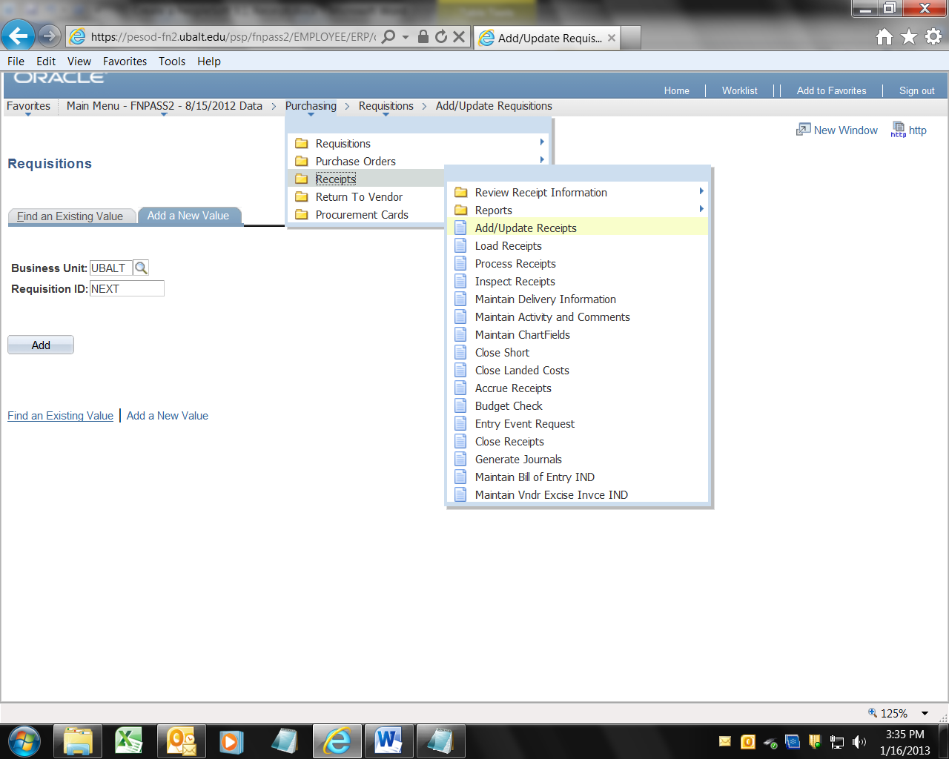
From the “Add a New Value” tab, click the button labeled “Add” | 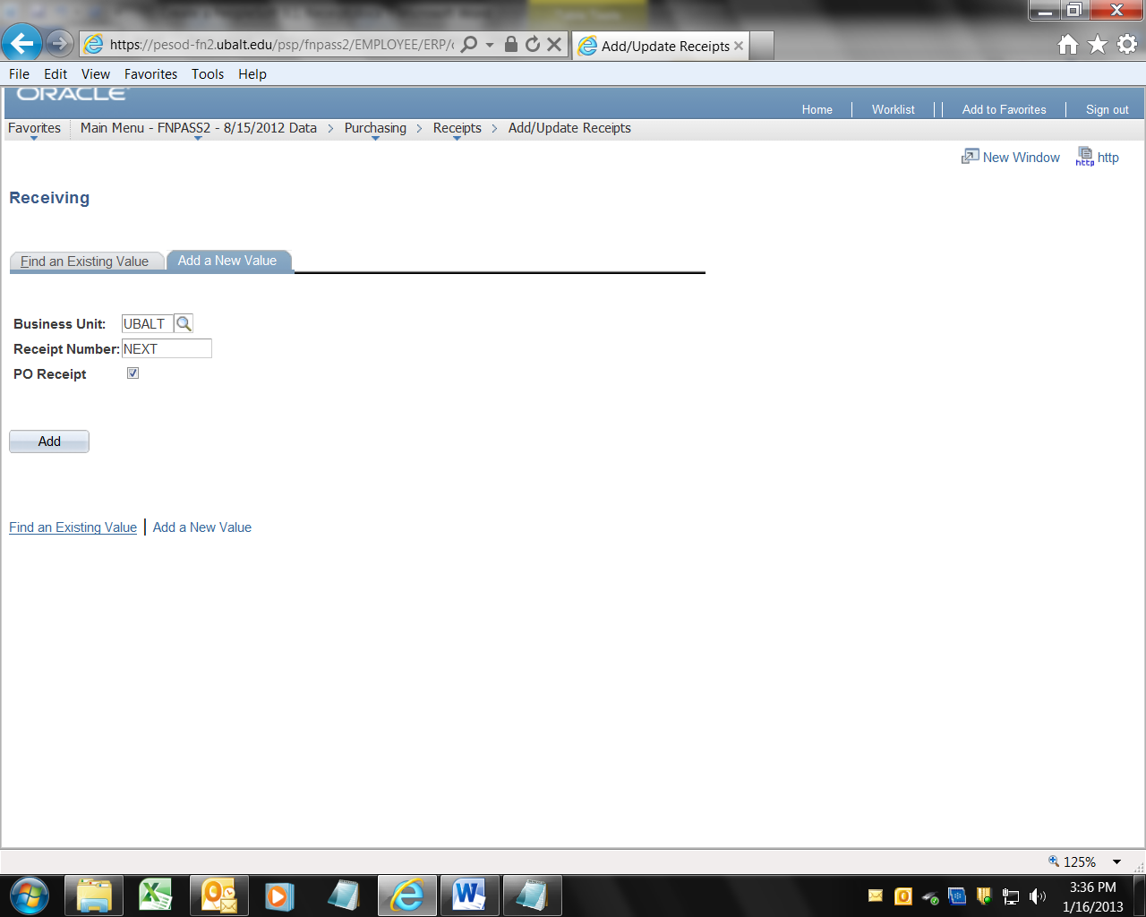
Enter the 10 digit PO number in the field labeled “ID:”  Then click the button labeled “Search”. | 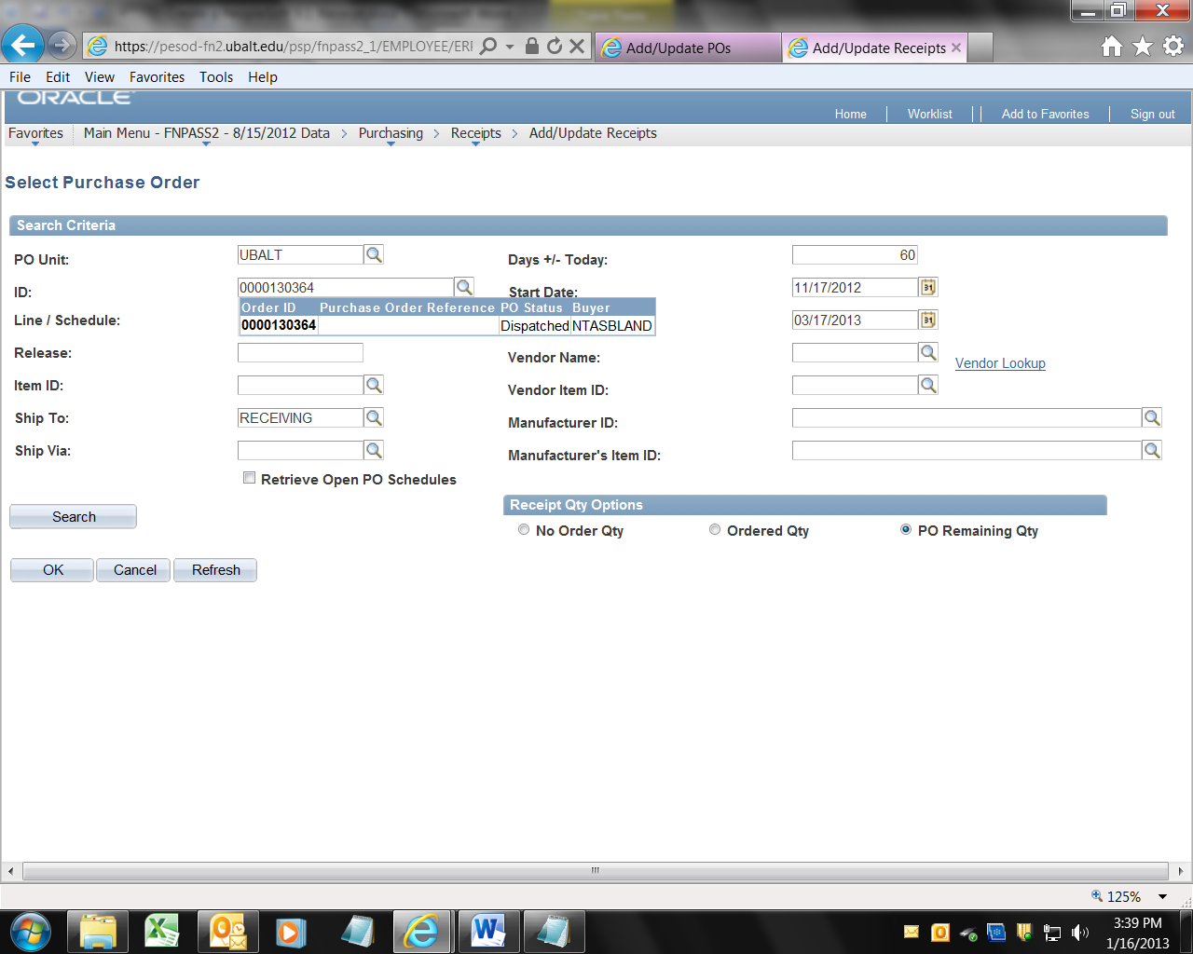
Note that the PO line information has been entered in the “Retrieved Rows” area.  Note that a PO may have multiple lines, so PS wants you to select the line against which you want to Receive. There may only be one line (as in this case) but you need to select the line, by clicking in the “Sel” box.  Then click the button labeled OK. | 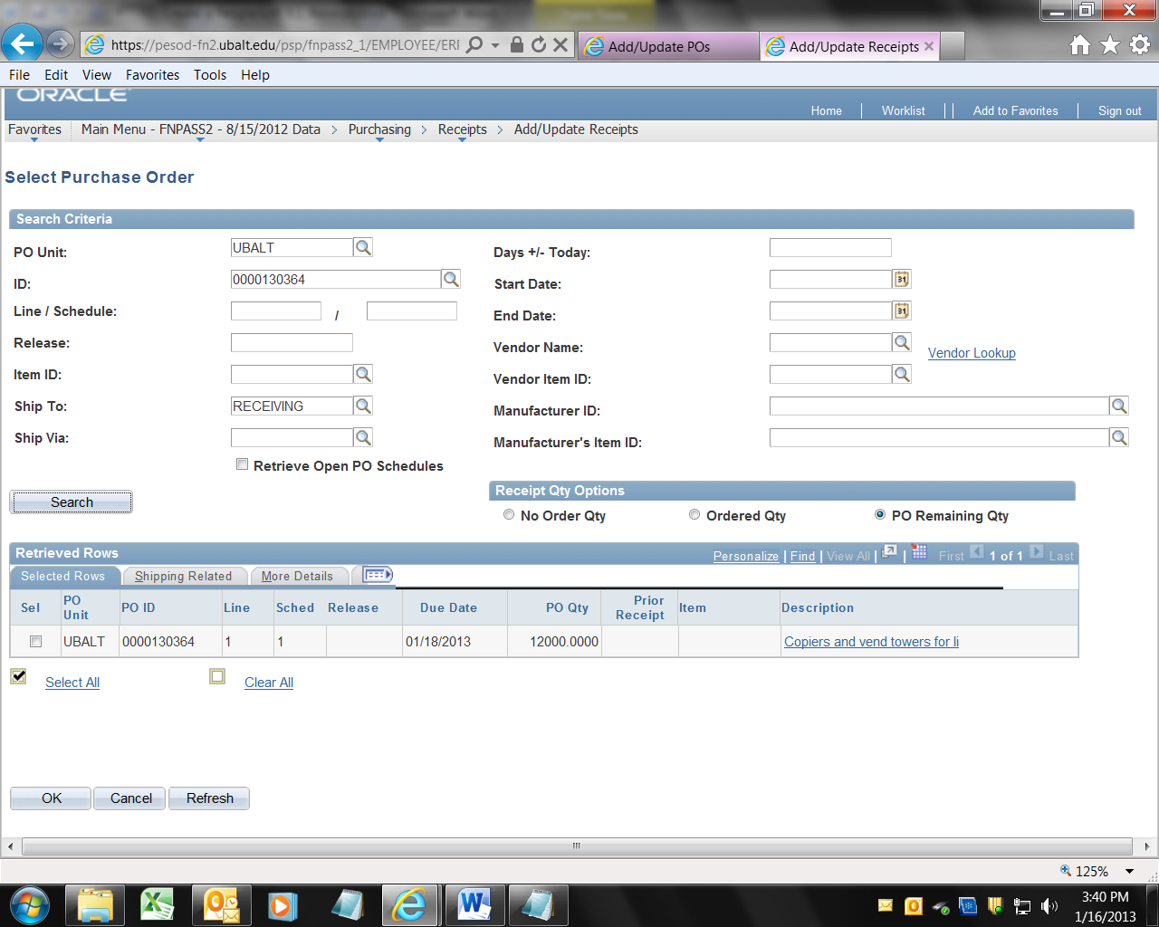
PS will present you with the Receiving screen, with the remaining PO quantity in the box labeled “Receipt Qty.”  Enter the amount you actually want to receive. If it is the suggested amount, just click the button labeled “Save”. | 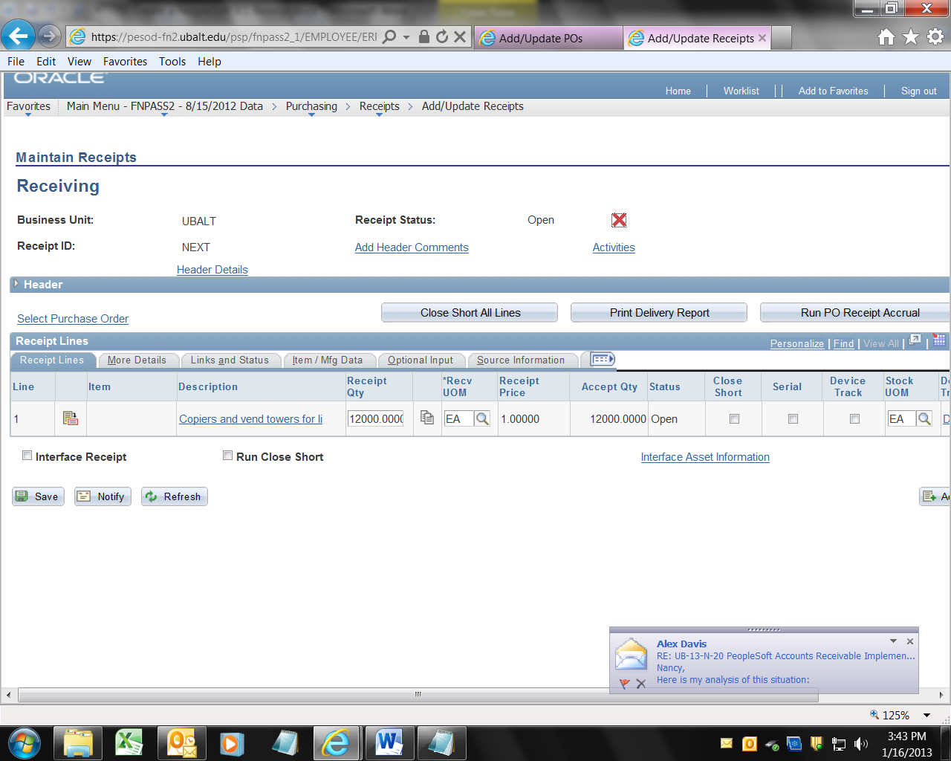
In this example, I changed the quantity from 1200 to 800.00. Note the “Receipt ID” (in this example, 0000047747). | 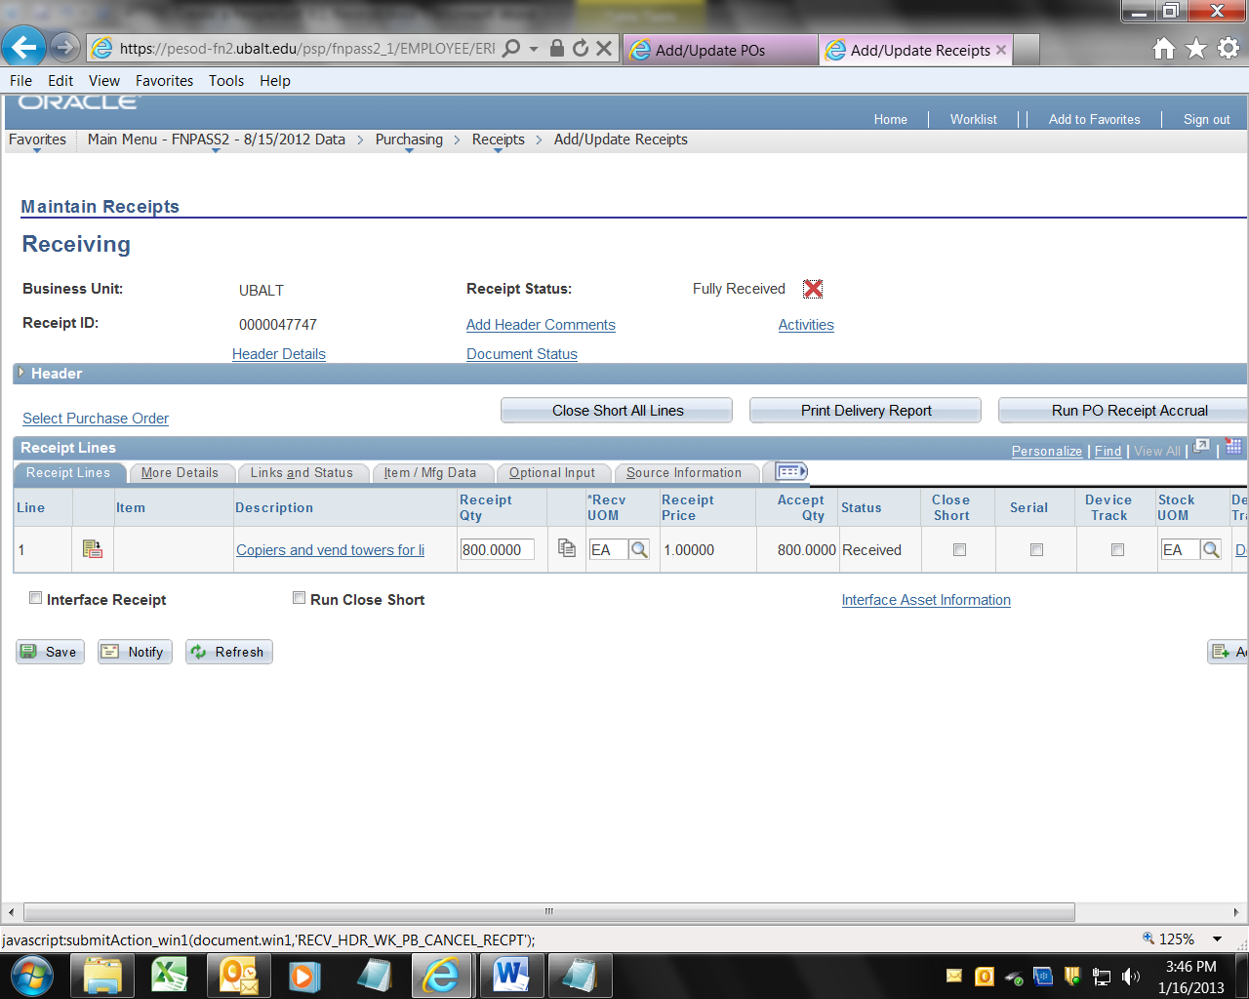
Done. Write the Receipt number and the PO number on the invoice, and send the invoice to Accounts Payable for processing.

