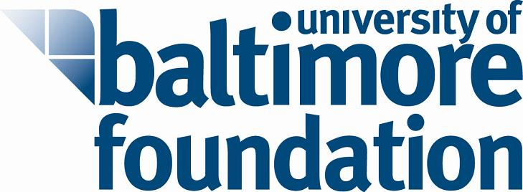

# | Proposal | UB Department | Amount | Notes
1 | BNIA - Community-Based Indicators | MSB | $17,250 | Build a community of UB data users, learners and researchers for quality of life indicators for Baltimore neighborhoods.
2 | Cloud Computing | MSB | $12,000 | Investigate use of cloud platform to support instructional technology needs of IT management program.
3 | Community Engagement Corps (CEC) | CPA/EMSA | $24,800 | Develop & implement University wide community engagement corps of students focused on Central Baltimore neighborhoods.
4 | Community Services and Civic Engagement (CSCE) Program Revitalization | CPA | $14,981 | Research & develop the CSCE degree program.
5 | Environmental Sustainability and Human Ecology – Equipment | CAS | $23,289 | Two pieces of equipment: Data Logger, Muffle Furnace
6 | Geographic Information System (GIS) courses development | CPA | $23,470 | Develop one undergrad and one graduate course in Geographic Information Systems.
7 | MOOC (Massively Open Online Course) development | CAS | $21,586 | Develop & deliver first MOOC course with Taylor Branch- Pulitzer prize winning author on the US Civil Rights Movement.
8 | Student Governance and Leadership seminar and mentoring program | CPA/EMSA | $1,618 | Originally approved for $8,095. Program completed under budget.  Implement 3-credit student leadership & governance program.
9 | Symposium Visioning for Excellence: Symposium on the Future of Integrative Applied Liberal Arts and Sciences at UB | CAS | $15,000 | Five- month symposium to facilitate campus-wide discussions integrative applied liberal arts; Each month a thought leader will be invited to speak. Will help CAS leaders frame and identity and vision for the future.
10 | Writing Program – Graduate Teaching Assistants program for two semesters | CAS | $25,000 | First time use of graduate teaching assistants. MFA graduate students will teach expository writing courses.
11 | SavorUB Program | Institutional Advancement | $1,000 | To expand program of sponsoring one-on–one meetings and informal mentoring for students and alumni.

# | Proposal | UB Department | Amount | Notes
12 | Global Field Studies Program in General Education | CAS | $18,470 | Expand opportunities for global studies to all UB students.
13 | Empowering Students for Professional Success | EMSA | $8,095 | Expand model developed by MSB to educate students about career planning and professional presentation.
14 | Hispanic Students Moving Forward: Building Partnerships | CPA | $24,733 | Development of a collaborative program with area high schools to help Hispanic students in Baltimore achieve success in high school and support their aspirations to attend college.
15 | Faculty and staff retreat as part of Law School’s long-range planning process | Law | $24,469 | Retreat focusing on enhancements & innovations in the law school curriculum & the student experience.
16 | Finding Justice – History of Women Lawyers in Maryland | Law | $25,000 | Support publication of a book highlighting the development of women in the law in Maryland and nationally.
17 | Microbial Source Tracking in the Lower Jones Falls | CAS | $23,645 | Two pieces of equipment: real time thermocycler, microtube homogenizer
 |  | TOTAL | $304,406

